Monthly Pro-Life Rosary – 6:30pm: Fr. Paul Chovanec led the Rosary for Life before the meeting.
Meeting: Called to order by Chapter President Robert Alcala at 7:25pm.
Opening Prayer: Rev. Paul Chovanec Chapter Chaplain lead all in prayer.
Pledge of Allegiance: District Master James Hatcher lead all in the reciting of the Pledge of
Allegiance.

Memoriam for Deceased Brothers:
A moment of silence was called for our Brother Knights that have passed on to their eternal rest during the period from the previous meeting: Walter B Davis III – Council 14512, SK Joseph Brown – Council 14512, James Broussard – Council 14512, SK Jerry Reder - Council8404/Assembly 1141,
Mark Evangelista - Council 6234, SK Steve Patrick Spenser. Chapter President called for a moment of silence. Vincent Stasio, Chapter Vice President, moved the memorial chair to its place of honor at the head table.

Chaplain’s Report: Fr Paul Chovanec:,
Worthy State Officers, District Deputies, Chapter Officers, and Dear Brother Knights.
Reflections on this month of October.
Columbus Day, October 12th. This is a good time to get excited about the completion of the enshrinement of the statue of Christopher Columbus and placing it in a place of honor. Praise him for his ideals of braving the open seas, the intelligence he applies to his voyages and creativity to visit the new world and share with the old world. Let’s defend our namesake.
Pro-Life. Lots of activities and prayers raised to heaven in the defense of the sacredness of human life in all its stages.
Holy Rosary. Feast of the Holy Rosary was yesterday October 7th. It was World Rosary Day. When we pray the Rosary we can gain a Plenary Indulgence, that means we can get a soul out of Purgatory, if we meet all the requirements. The requirements are the Rosary must be prayed in a church or in a group such as a family, Knights of Columbus, or another religious group. Pray for the intensions of Pope Francis, which can be found in the Columbia Magazine monthly. Get to Confession and Communion in a reasonable number of days. The other requirement is rather vague. No attachment to sin, which means you do not attest to sin or justify it. To be priest
Fr. McGivney Statue. We should also get excited about the Fr. McGivney statue at the seminary. We need to stay on top of this so that it will be accomplished. It will be a good example of all those young men studying to become priests.
That is the story of the month of October. God bless you one and all.

Secretary’s Report: Chapter Secretary – Bob Schmidt
Tonight’s attendance is as follows: 40 Members
11 Guests
19 District Deputies
Since this is a new Fraternal Year each member council needs to complete a new Chapter Delegate form. This form can be found on the GHKNIGHT website. Completed forms can be sent to myself or our worthy Chapter Treasurer.
The minutes of the September meeting have been posted to the Chapter website. Are there any corrections? Motion was made to accept as posted and seconded. Discussion, Discussion, Discussion. Hearing none, minutes are approved as posted.

Treasurer’s Report: Chapter Treasurer – Charles Cantrell

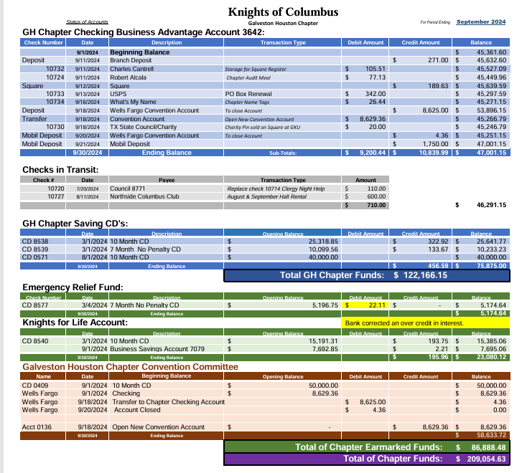
Chapter per-capita statements were sent out in the beginning of this month. Please look for this in your emails.
Today is the last day for the early-bird Clergy Night reservations. I can take a check or credit card if you want to secure these. After today the price per seat goes to $50.00.

Chapter president asked for a motion to approve the Treasurer’s report as presented. Motion made and seconded. Then asked if there is any discussion, discussion, discussion. Hearing none, vote to accept the Treasurer’s report was approved.
President’sReport: Chapter President Robert Alcala

Father Paul, Worthy State Secretary, Past State Deputy, Diocesan Deputy, DDS, Delegates and Brothers all.
Welcome my brothers. I pray that you've been able to participate in your civic duties and prepare yourselves for our upcoming Presidential elections. Whether you are Democrat or Republican, Libertarian or Green Party, you are a Knight of Columbus. We are called to a higher civil participation, in addition to our undying support of the Catholic Church. Don't ever let it be said that you did not have a part in forming these next 4 years. As a non-profit charitable organization, our order is legally prohibited from endorsing political candidates in the United States, but we are permitted to engage in issue-specific political campaigns. Continue your support of the proper social teaching of the Catholic Church and those issues that could affect our insurance programs.
In addition to our civic duties, and in line with our pledge to stand in solidarity with our priests, let us not forget one great way that we demonstrate that pledge...Clergy Appreciation Night.
Brothers, we need to get those Table registration forms turned in as soon as possible. Several of the premium table locations are already being taken up, so its important that you don't delay. Send in your forms and money asap. Our Worthy Chapter Treasurer is ready with his handy dandy credit card reader to take your payments tonight. Remember— tonight is the deadline for the early bird discount. Starting tomorrow, the price per seat will go up $5.00.
In addition to the table registration forms, I plead with you to turn in your Clergy of the Year nomination forms. I sent those out with the last email distribution, so if you are not receiving my emails, please see me after the meeting and I will get you added to the master list.
January 7, 2025— Last day to Register for the Event. There will be NO reservations taken after this deadline.
DDS and GKs, please, please, please — make sure that your Pastor, priests and Deacons have received the invitation that went out last month. Make sure it didn't go to their spam or trash files. GKs, you should be inviting them personally, so they know you care about them being recognized for all the good they do for us. Their invitations directed them to let you know that they were interested in going. Make sure you close the loop and then, get your registration forms turned in early.
Tonight, under old business, our Worthy Chapter Vice President will provide you a brief update on the Christopher Columbus statue. This is a project that I would really like to see completed this fiscal year.
And finally, our Worthy Chapter Treasurer will present our new proposed budget for this upcoming year. Please pay close attention to the budget. Charles has put in many hours of thought and has the support of the Finance Sub-Committee for the version which will be presented tonight. Tonight, will satisfy the first reading and the budget will be posted on the chapter website — under Member Resources, following today's meeting.
Now....Let us hear from our Worthy Chapter and Diocesan Committee Reports.
Chapter/Diocesan Committee Reports:
Bob Schmidt – Youth Program Chairman
We are in the middle of our Soccer Challenge. The councils should have completed their Challenges, and the District Challenges should be completed this month. The Diocesan Challenge will be taking place at the same location as last year, Strake Jesuit High School in Bellaire. This will be on Saturday November 9th at 9am. We need volunteers to man each goal.
Also coming up is the Essay Contest and I will be needed judges. Please contact me if interested. The district contests should be completed in November and the winners of you district turned in at the December Chapter Meeting.
The Keep Christ in Christmas poster contest is just around the corner. Watch the schedule that was handed out in July.
We have a new program coming up which is the Corn Hole Contest more information is forth coming.
George Brooks – Culture of Life
Culture of Life Director's Report, Oct. 8, 2024
Knights of Columbus, Archdiocese of Galveston-Houston
Worthy District Deputies:
We are now well into the Respect Life Month of October with MOTSY, the March of the Surviving Youth, last Saturday, and then Respect Life Sunday.
We are reminded that our fundamental Catholic beliefs demand respect for the life and dignity of all persons from conception to natural death. When Jesus told us we must love one another, it was not merely a suggestion. As Catholic men and Knights, we obey this commandment in two fundamental ways.
1. We show our love for others by raising money to donate to entities that can help meet the material and spiritual needs of others. That is the fundamental and basic principle of our order.
2. Our ACE Wings program connects us to unborn persons and calls us to both prayer and activism. At the same time, we become directly involved in making a difference in the lives of others through activities such as Special Olympics, the American Wheelchair Mission, and VA Visitation.
Let us encourage all of our brothers to participate in activities that qualify them to wear the ACE Wings so they also declare respect for life and human dignity without Apology, without Compromise, and without Exception.
I hope every parish has Pro-Life activities this month. My parish, St. Mary Magdalene in Humble, has a Rosary for the Unborn on October 13 and a March for Life around the campus on October 27, as well as the Silver Rose ceremony also on the 27th. Our parish Respect Life Ministry will also participate in a 40 Days for Life event on October 19. I hope many parishes will also be participating sometime during this fall campaign, which ends November 3. https://www.40daysforlife.com/en/
Brothers, we are all keenly aware that we are in a season where we will select the future leadership of our country. All of us have seen ads on TV recently that make Texas laws protecting the lives of unborn children look harmful and cruel. Those seeking to profit from such ads are unrestrained by a need to be truthful, and indeed the ads are designed to frighten women and try to influence the voting preferences of low-information voters.
I have been asked to write an essay on the history and facts surrounding the relevant laws in Texas. I will post it on my web site https://buildingacultureoflife.org/ under “Current Events” within a couple of days. Subscribers will get automatic notification when it is posted, so do not be shy…but I will send you a link in case you want to read it. Whereas political rhetoric always contains hyperbole in order to make a point, it is wisely said that the truth sets us free, and I confess that it makes me angry when people are manipulated by outright lies in order to gain political power and money.
I wrote my book Building a Culture of Life and developed the web site in order to inform and educate. In the book, I recite data on why women get an abortion. In a follow-on lecture that I give on the future of the Pro-Life movement, I make the case that we must continue to do all of the things we are doing now, but we must also work to change our society.

We must honor motherhood, so that women who have an unplanned and unwanted pregnancy, often in awkward or extremely difficult circumstances, do not feel overwhelmed and desperate but are honored and celebrated. There must be solutions of which women are aware so that they do not feel driven to abortion by thinking that abortion is the only practical choice, which they hear all the time.
The narrative promoted by those profiting politically and financially is that a pregnancy will ruin their lives and take away all their opportunities for education and careers, that they can’t afford housing, that they will spend all their money on day care, or that their child will be a burden on society and become a criminal…that the responsible thing to do is to get an abortion.
However, my book also cites the emotional impact and destructive behavior that many women suffer for years after an abortion. Abortion is not the answer. Going forward, we must provide real answers, real solutions. We must select the right leaders and demand that they address the issues that drive women to abortion. Then, women will protect their own babies.
Let this be the year that we begin to change our society to a Culture of Life, and in doing so, let us pray that we will also change the world away from a Culture of Death.
Chris Peralez – VA
I have a few of the new VA Visitation Schedule. It can also be found on the Chapter website. This past Sunday we had 16 brothers from 5 different councils visit our vets. They were from Council 10959, 6234, 8404, 3910, and 4550. Thank you for your support in visiting our vets.
Thanks, and God bless. Vivat Jesus!!
JL “G” Giegerich – Emergency Response
Over a year ago Supreme changed the guidelines for Disaster Recovery efforts. Now all those that want to assist those affected by a disaster should forward all funds to Supreme to be dispersed. They know what the needs are and exactly where needed.
This can be accomplished by logging on to KofC.org, Donation Tab, Disaster Relief Section, make sure you complete the memo section as to what disaster you want to support. You can also mail a check, note the disaster you want the money to go to in the memo section of the check.
Knights of Columbus
P.O. Box 1966
New Haven, CT 06509
By dong it in either of these manners makes it more efficient and the money gets to the exact area you would like.
Please keep those affected by Hurricane Helene, and this new Hurricane Milton in your payers.
Manny Cruz – Special Olympics
Lots of activities for Special Olympics this Month. Starting off this Friday with Breakfast for Champs. Come and learn about Special Olympics.
Saturday October 12th – Bellair Highwater Truck Pull and Car Show.
Saturday October 19th – East Region Bocce Tournament
Monday October 21st – 2nd Annual Gulf Coast Golf Tournament, League City CC
Saturday October 26th – Rescheduled East Region Softball Tournament in Pearland
Saturday November 2nd – East Region Volleyball Competition
Monday November 4th – Arca Coca-Cola Golf Classic, The Woodlands CC
Thursday November 7th - East Region Fishing Tournament, Lake Jackson
Sunday November 10th – Chicken N Pickle Tournament, Webster
All the information on these events can be found on the Chapter website.
Thank You.
John Williams ADD -Wheelchair Mission
As of September 30th – 8 Councils in the Galveston-Houston Diocese have contributed $10,870. When comparing that with last year at this time we had 14 councils contributing $36,011. We are behind last year by about $25,000. The diocese up north is ahead of us with donations of over $40,000. Let’s step up our game and be number 1.
We have requested one container of wheelchairs be brought to the archdiocese. Final approval has not yet been received. Our inventory is very low, less than a dozen wheelchairs. Once we get the container in which would be sever months out, we will need a storage location. Please keep this in mind if you have some storage space that would be available.
Again, requesting all councils, this is in conjunction with the State, to donate at least $150, the cost for 1 wheelchair and the District Deputies to hold at least one Wheelchair Weekend in their district. If you make a $500 donation you will receive a framed lithograph of Our Lady of Guadalupe.
Thank You very much.

Old Business
Vincent Stasio – Christopher Columbus Statue
The Christopher Columbus Statue that is to be placed at Annunciation Church is moving forward. I have a couple of solutions as to the direction we want to proceed. This needs to be discussed with the chapter officers and a firmer report will be given at the next meeting.
So far, we have accomplished the purchase, repair, and taken possession of the statue. We have received bids from 5 different contractors based on our proposed plan.
As I stated I will have more to report at next month’s meeting.
Thank you.
New Business
Don Kresse – District Deputy 99
Asking for help supporting Conroe council 6458 in putting on the Seminarian’s Confab and Retreat – Lake Conroe, Texas, August 2025. This was put on in previous years, but not last year. Fr Richard McNeillee, Director of Vocations, has requested we reinstate this retreat in the Summer of 2025. Since the number of seminarians has increased so will the amount of money and assistance that will be needed to accomplish this event. A ny help will be appreciated. Below are some details of the event.
Conroe KC Charities
In Service to Our Community*
P. 0. Box 3668 (832) 524-8186
Conroe, Texas 77305 Fax: 800-694-7303
SEMIARIAN'S CONFAB AND RETREAT- Lake Conroe, Texas August 2025
Back in 2019, our Conroe Council 6456 was asked by our pastor if we would assist with a facility and activities where the Seminarians from our diocese could gather in an informal venue for relaxation, recreation, prayer, brotherhood, where they could get to know one another in their journey to priesthood, to share and reflect. My Brother Knights, their wives, and friends of our Council, put together the money and venue for a very successful 'Confab 2019' for over 60 seminarians at 'Camp Gregory'. Money was raised, logistics were worked out, meals were planned, and the weeklong Confab turned into Confab 2019, 2020, 2021 ,2022, and 2023. Father Richard McNeiLlee, Director of Vocations, gave us a year off in 2024, but we are back for Confab 2025 this coming August.
We provide swimming, fishing, boating, jet skis, tubing, volleyball, lounging and other sporting activities, peaceful and private areas for them to meet, and just a great 'lake in the country' environment to reflect and enjoy.
We have been told to plan on about 75 seminarians this year and are already making plans. If you or your Council, or any other organization or person would like to help our Council with a tax-deductible financial donation to make this another successful Confab, we could sure use your help. We feed, lodge and entertain all the seminarians who attend, make sure they have what they need, and make sure they are comfortable and well fed.
We do this, not for recognition, but for the good of our church's future. We do this each year at no cost whatsoever to the diocese or the church, from donations. if you can help, it would be certainly appreciated. What do we need, you ask?
- First, money donations in any amount. Thank you, letters are sent to every donor.
- Air-Conditioned camping trailers you could loan to for this event. Full hookups on site.
3 Triton boats, especially with 'captains' for one day for 'Lake Day', usually, Thursday.
4 Our council's members, and Spirit Cookers, a local non-profit cooking group, and others provide bar b q and steak dinners, and if any other groups out there would like to donate cooking dinner one night or just pick up the tab, we can accommodate and do appreciate.
For more details or information, please don't hesitate to give me a call, Thank you,
Dan Gregory Past Grand Knight Conroe KC Council 6456 832-524-8186
Charles Cantrell – Budget 2025
Please review the proposed budget for the year 2025. It will be voted on at the November meeting as it requires two (2) readings. See the budget Below:

It was open to questions. There was a couple, and they were answered.
Chapter President asked for a motion to approve the Budget as presented. The motion was made and seconded. It was then tabled to the November meeting for final approval.

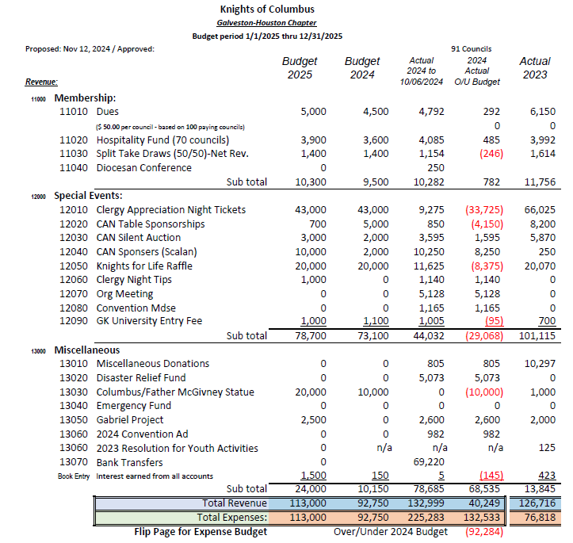

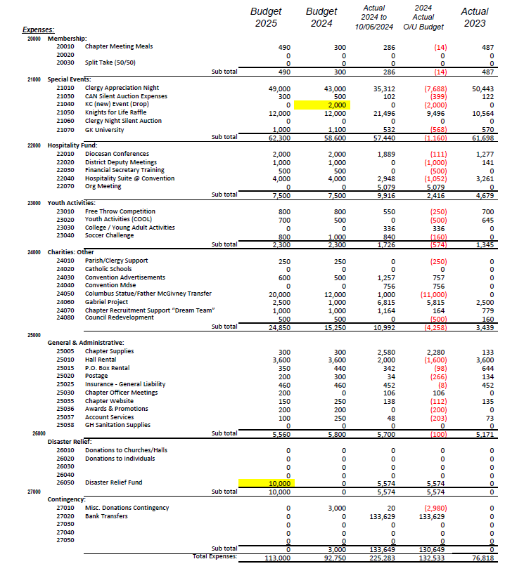

Diocesan Deputy Report – Ron Frerich
The state deputy wanted me to send his greetings and thank you for the great job recruiting this past month. We set an all-time record in the state. He will be in the area this month attending CUFs. He will be in Galveston, council9978, on October 13th. At U of H, council 15105, on October 14th. They are quadruple star council as of now. On October 24th at the CUF at council 2719, Houston. He will also be here 3 more times to present checks in the amount of $25,000 to 3 parishes that sustained damage during hurricane Beryl. They are St Joseph, Baytown, council 2788, St Christopher, Houston, council 16218 and St Augustine, Pasadena, council 3700.
After the first of the year we will have the Blessed Michael McGivney relic here in Houston.
January 6th – Mary Queen, Friendswood
January 7th – St Charles Borromeo, Houston
More details will be coming as the events are firmed up.
There was a membership contest for the first quarter, and I won the Division One award. So, I decided to share this award with the councils in the diocese that did the best. Council 6878 and 15105.
We set a record for Star Districts. I would now like to present these awards to the recipients.
Please stay on top of the Safe Environment Program in your council as well as your district. We are way behind compliance again this year. You need this for Star Council and Star District. Protect yourself.
We are doing a little better on Fraternal Benefits but we still have a long way to go.
Read your emails from State. They are sent via Constant Connect and they know who does and who doesn’t open the email.
Make sure your council has an EFF Director. Don Hensley is the Diocese Director.
Use the new meeting agenda, it keeps new members coming back.
Grand Knights please post a yearly calendar of council events.
We need to recruit this month to help make up for the slow down during the holidays.
State Committeeman and Master Report
Bob Schmidt – State Charities Committee
At the end of September Galveston/Houston contributed $118,495 toward the goal of $168,455. This equates to 70% of the goal, but when you add the additional 20% that state is looking for, this brings us to about 59%. Remember Charity Pin contributions help in making this goal and should be used to help your council achieve the 120%. So far we have about 62 councils at 100% or more and 2 councils over the 120%.
Right now it looks like about 50 councils will achieve the Quick Start Award as well as 5 Districts. Remember we have just 3more months to achieve this award.
JD Gurtierrez – State Memembership Committee
Currently Galveston/Houston sits at 3rd place in division one, behind Dallas and San Antonio. Statewide we are at 45% of our goal and G/His standing at 28%. There are still a lot of E-members out there that have not gone to a CUF. We are encouraging you to work on your Prospect List and get those members to a CUF.
This month there is a District Deputy contest that requires you to get 50% of your membership goal before October 31st. If you achieve this your name will be put in a drawing for a cruse.
Statewide there have been 467 CUFs recorded ytd. In G/H 25 districts out of 38 have reported a CUF. Districts 75, 87, and 93 have completed over 10 CUFs reported in the system for us. We lead the state with 134, which is 36 per month, but now we are only reporting 12. Please make sure you use the forms necessary to make the reports.
District Deputies you need to be looking forward in your planning, as this is how you accomplish the needed results for Star Council.
Thank You.
SK James Hatcher – Master of the First District of Texas
First off, I would like to thank all the Sir Knights that came to serve in the month of September. September was a very busy month, especially the week of September 22nd to the 29th. That week started off with the 50th Golden Anniversary Mass with Cardinal DiNardo at the Co-Cathedral. We came together to celebrate the life of Father Drew Wood at St. Laurence. I also had a funeral for a friend and Sir Knight. We came together to serve at St. Anne’s in Tomball for a Confirmation Mass with Bishop Italo. The Relic of St. John Paul II came to 5 parishes and 3 schools in the archdiocese. Sir Knights came from all over the diocese to serve as Honor Guards for the veneration of our late Pope and Saint of our time. We concluded the week with the Blue Mass for Law Enforcement at the Co-Cathedral with Cardinal DiNardo. This was just one week in the month. Again, thanks to all that came. I know many sacrificed personal events to come and serve.
This past weekend we held our Annual Provincial Meetings in San Antonio. These meetings go over our responsibilities and goals for the year. Where are we now in the fraternal and where we plan to be at the end of the fraternal year. It is not unlike the meetings our Diocesan Deputy attends. One item discussed was next year on February 22, 2025, The Fourth Degree will celebrate its 125th anniversary with an exemplification at St. Patrick’s in New York City with Cardinal Dolan as the principal celebrant. Besides celebrating our 125th anniversary, Supreme will issue in the new exemplification for the 4th degree. The new ceremony will allow families to attend and witness the knighting of all candidates in attendance.
This coming weekend of October 11 & 12 will be our Fall Exemplification at St. Jude Thaddeus in Beaumont. I hope many of you will come down and support the exemplification. It’s a short drive and St. Jude is a beautiful church. Our keynote speakers will be Bishop Toups of the Beaumont Diocese and our very own Texas State Council Secretary, Bob Goss.
I have left flyers on the informational table for upcoming events for the remainder of October. Sunday, October 13 will be the Firefighters Mass at the Co-Cathedral
Wednesday, October 23rd will be the Annual Red Mass for Legal Professionals at the Co-Cathedral. Tuesday, October 29th will be the Annual White Mass for Catholic healthcare workers at St. Anne’s on Westheimer.
Earlier, I mentioned how busy we have been. The 4th degree is called upon by our pastors and our Cardinal to serve in special ways not available to our Brother Knights. We have a new motto in Our Lady of Guadalupe Province that simply states, “We Got This”. When we are called, we want to answer that call to serve. That is why we become Sir Knights of the Fourth Degree.
God Bless,
Bob Goss - Worthy State Secretary
Thank you each and every one of you for everything you do. Please communicate to your councils how much you mean. As I mentioned before it was G/H that moved us back up and over the top. It is super critical that we recruit now. Build up your resources now as you know the numbers drop in November and December. Now is the time to plan you recruiting for the next months.
I have previously told you how Safe Environment is critical to your council. Make sure your councils are covered and those that need it are in the process or have completed the requirements.
On the same note, make sure you are not by yourself when in the company of women and children at events around the council and the parish. This way there is a witness if anything comes up later. Protect yourself.
The Bob Goss incentive is a dinner out for GK and 3 others of his choosing. You just must be the top performing council in your division as of December 31, 2024.
God Bless, Thank You.
Terry Fruge’ – Immediate Past State Deputy
A special thanks to all the past year District Deputies that received the Star District awards, it was a great effort, and I know you all will do even better this year.
I have been asked how it has been since handing over the reigns to our new State Deputy. Well things have slowed quit a bit. Had a new grandbaby and also been able to do some relaxing travel.
Hope you didn’t miss the webinar featuring our State Deputy Ron Alonzo on Funeral Planning this last week, it was very informative. He gave a lot of information on what to expect when you are in this situation. He talked about how to plan for your or a family members’ funeral. Also how to prepare your family.
In speaking to the State Deputy today I asked if he had any comments to pass on. He just said Grow the Order.
Keep doing the great job you do. God bless you.
District Deputy Reports
District 75 – we have those recruitment banners over there for sale at $65 each. Also I call your attention to a special CUF to be held this Sunday Oct 13th at the VA after Mass. Fr. Innocent is going through the CUF.
District 99 – CUF at U of H at 4pm on October 14th. State Deputy will be in attendance.
District 74 – CUF at council 8960, Pearland, October 17th at 7pm
District 68 – CUF at council 10393, Hitchcock, October 14th at 6pm
District 92 – CUF at council 12320, Kingwood, October 14th at 6:30pm
District 85 – CUF at council 9708, Clear Lake, October 26th at 10am
District 71 – CUF at council 12955, Katy, October 26th at 9am
Grand Knight Report
Council 10574 – Deer Park, CUF, 10/22
Council 3217 – Dickinson, Shrine of the True Cross, Fall Festival, 10/20, Special Car Raffle, $20/chance
Council 10390 – St Vincent De Paul, Houston, Tomorrow first COR meeting, 11/2 Pancake Breakfast and Kids Costume Show, 11/19 &20 Fall Festival
Council 10861 – St Ignatius, Spring, 10/12 Silver Rose, 11/2 Breer Brott Fest, 11/6 Mass for deceased council members, 11/10 VA visitation
Council 4550 – St Gerard, Houston, CUF 10/17, District Soccer Challenge 10/26
Council 6878 – St Mary Magdeline, Golf Tournament 10/12
Council 8482 – Prince of Peace, Houston, CUF 10/13, 6:30, Build a Bed Project, 11/9, Will be building 75 youth beds
Council 9310 – St Mary of the Expectation, League City, Fall Festival 10/13
Council 4204 – St Theresa, Sugarland, COR meeting in the morning, 10/17 & 24 Last sessions of Mission of the Family, 10/18 Fish Fry, Last 2 weekends hand out Novena for Life prayer cards, 10/26 Rosary to start Novena, 10/27 Life Chain Event
Council 6547 – St John Vianney, Houston, Sunday 10/13 is Deacon Sunday, 50-year anniversary of the parish celebration 11/9
Council 3217 – Father Roach Council, Dickinson, To receive 75yr of Service to the Order Award
The 50/50 Drawing
Amount $86.00. The winning ticket 4131105
Sick & Distressed Payer List
President Alaca called our Chapter Vice President, Vincent Stasio, to read the list. Let’s use this time to focus on the people who need our prayers.
Name Council/Assembly Reason
Walter McAndrews 12320 Dementia
Walter Davis 14512 RIP
SK Joseph Brown 14512 RIP
James Broussard 14512 RIP
Ronnie Price 13615 RIP
Peter Stasio 3910 Recovery Cancer Surgery
Thomas Pilcli 12385 Parkinson’s
Robert Parra 12385 Cancer
Norman Schenck 12385 Lung Illness
Llyod Sterling 8293 Cancer
Cody Davenport In Emergency Surgery
Davenport Family Support for Son
Sheryl Bowles 14700 Infusion Following Surgery
Thomas Bandzul Cancer
Charles Pipkins Memorial Cancer
Maggie Nelaj 9564 Stuck in FL with Kids
Maria Barajas 8293 Cancer
Angelia Gonzales 7382 Drugs
Rosa Gonzales 10390 Recovery from Cancer
Ann Bertini 10390 End Stage Cancer
Virginia Tubbs 10390 Surgery
SK Clay Hamann 14512 End Stage Parkinson
Baby Olvia Mangro 14512 6mo old Heart Surgery
Frank Martine 9564 RIP
Closing Prayer
Fr Paul led in closing prayer. For those named which we have been asked to pray, and for the people in Florida where this new Hurricane is headed. Let us use the prayer for the Canonization of Blessed Michael Mcgivney.
Meeting adjourned at 9:25pm. Next Chapter Meeting is Tuesday, November 12, 2024.
Attested: Robert Alaca Chapter President, Knights of Columbus Galveston/Houston
Attested: Robert Schmidt Chapter Secretary, Knights of Columbus Galveston/Houston

